

**SAMAR STATE UNIVERSITY**

Arteche Blvd., Catbalogan City, Philippines 67000

**College of Engineering**

**Differentiating Electromagnetic Waveform Characteristics of Electricity Generated by Standalone and Rectified-Filtered Piezoelectric Cells**

Case Study Proposal

Engr. Rojay A. Flores

**Subject Teacher**

Bodollo, Donald B.

Bol-anon, Savannah Joy L.

Perit, Renz S.

1. **INTRODUCTION**

Piezoelectric cells have gained attention as a sustainable energy source due to their ability to convert mechanical stress into electrical energy. However, the raw electrical output from these cells is typically irregular, containing fluctuations in amplitude and frequency, which may limit their direct application in electronic systems. To improve the stability and usability of the generated power, rectification and filtering circuits, such as bridge rectifiers and capacitors, are often introduced.

This study seeks to address the problem of identifying and understanding the differences in the electromagnetic waveforms generated by a standalone piezoelectric cell and one integrated with a DC regulator. By determining how the waveform properties vary between these two cases, this research aims to provide insights into the impact of DC regulation on the performance and usability of piezoelectric systems. The findings of this study will contribute to a better understanding of how piezoelectric cells can be optimized for practical energy-harvesting applications.

1. **MATERIALS USED**

The following materials are utilized in the creation of the project.

• Piezoelectric Cells (4 pieces)

• Capacitor (470uf, 10V)

• Soldering lead

• Lead

• Wires

• Vertical Tube (1 meter)

• Analog Discovery 3

• Laptop

1. **PROCEDURE**

This study examined the electromagnetic waveform characteristics of electricity generated by a piezoelectric cell under controlled impact conditions. The process involved circuit assembly, equipment setup, and systematic data collection to ensure accuracy and repeatability.

**1. Preparation and Setup**

a. **Circuit Assembly**

* The piezoelectric cell was connected to a bridge rectifier and an electrolytic capacitor in parallel to rectify and filter the voltage.
* Proper polarity was ensured when connecting all components to prevent errors in signal measurement.

b. **Measurement Equipment Connection**

* The output terminals of the circuit were securely attached to the Analog Discovery 3 for waveform analysis.
* The Analog Discovery 3 was linked to a laptop to facilitate real-time data acquisition and storage.

c. **Testing Environment Setup**

* The piezoelectric cell was placed on a stable, flat surface to ensure consistent force application and minimize external vibrations that could affect the readings.

**2. Data Collection**

a. **Standalone Piezoelectric Cell (AC Output)**

* Mechanical force was applied by hand, pumping the piezoelectric cell 20 times with even pressure to maintain consistency across trials.
* The Analog Discovery 3 captured the voltage waveform generated by the piezoelectric cell, and the data was stored on the laptop for analysis.
* The procedure was repeated for at least six trials to verify the consistency and reliability of the results.

b. **Piezoelectric Cell with Rectifier and Capacitor (DC Output)**

* The same procedure was followed, with force applied by hand pumping the piezoelectric cell 20 times.
* The Analog Discovery 3 recorded the waveform of the rectified and filtered output, and the data was stored on the laptop for further analysis.
* At least six trials were conducted to ensure the reliability and consistency of the measurements.

1. **RESULTS**

**Obtained outputs for Standalone Piezoelectric cells**

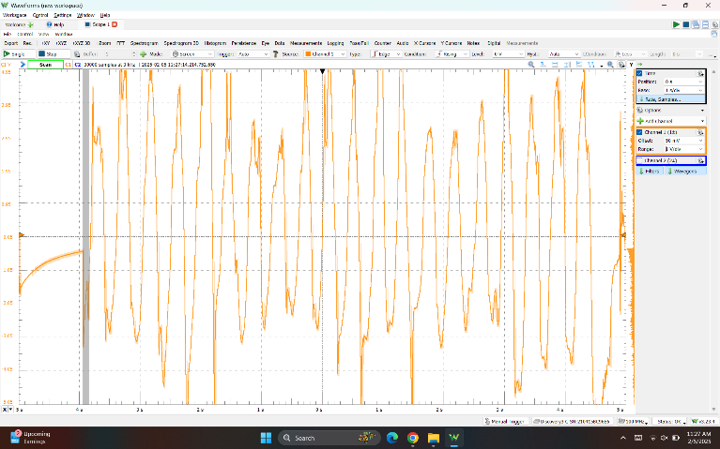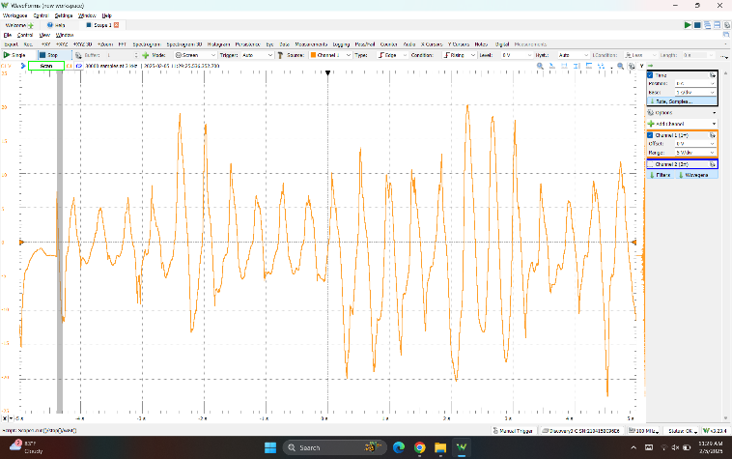

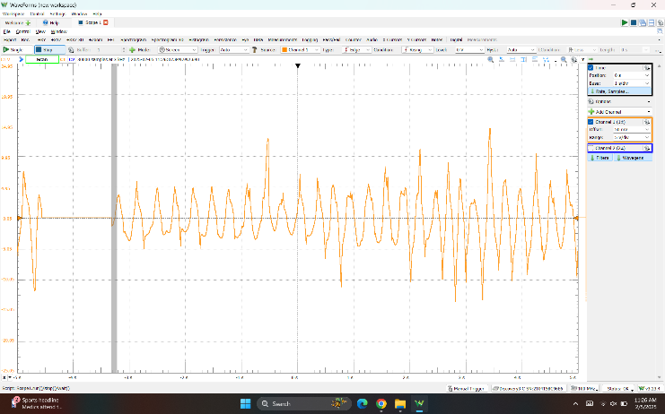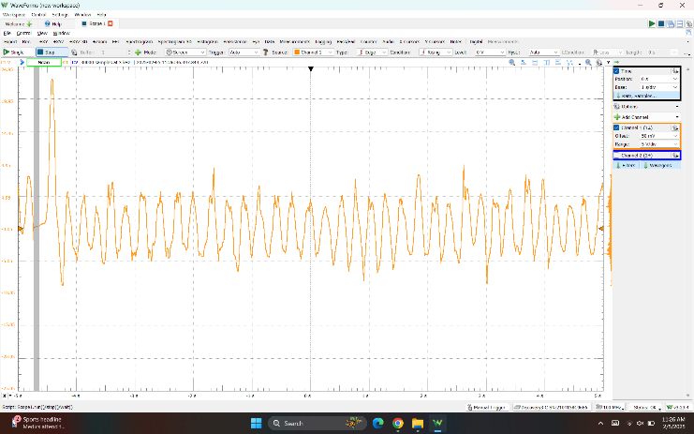

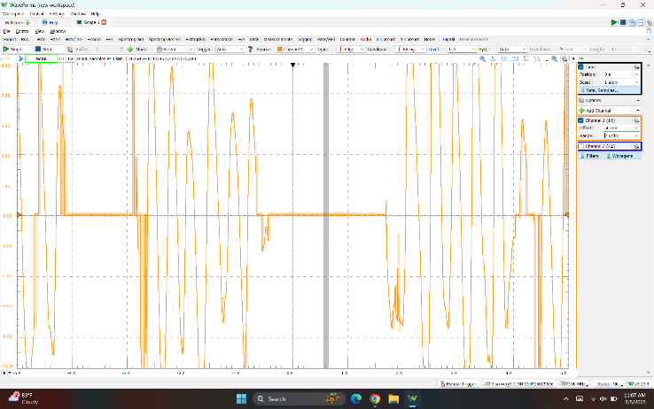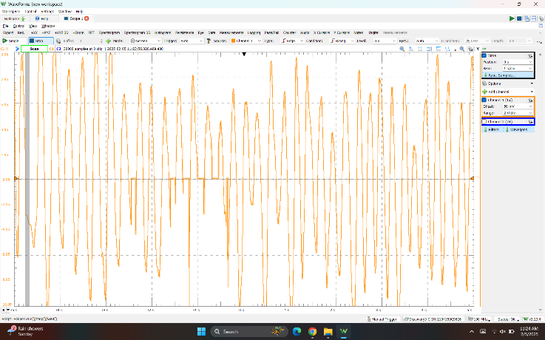

The voltage waveform from the standalone piezoelectric cell exhibited fluctuating amplitudes due to variations in applied force and material properties. High-frequency noise was present, likely caused by mechanical vibrations and uneven force application. The signal alternated between positive and negative values, indicating an AC output. Frequency variations were observed, reflecting inconsistencies in mechanical input. The overall waveform remained irregular and unstable.

**Obtained outputs for Standalone Piezoelectric cells**

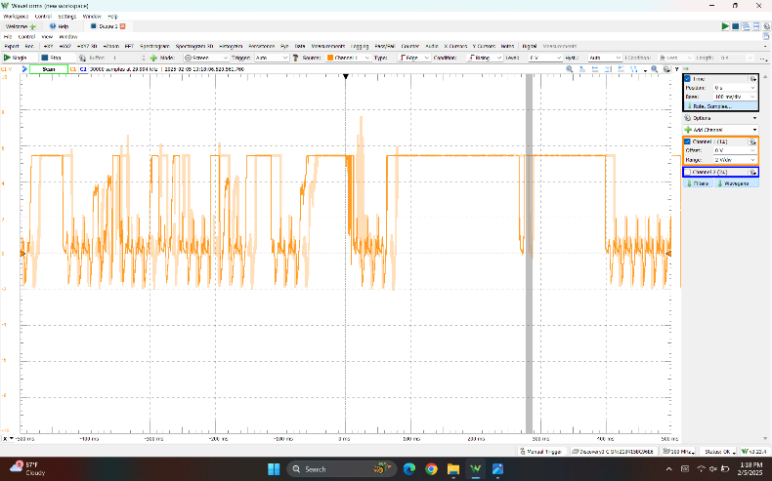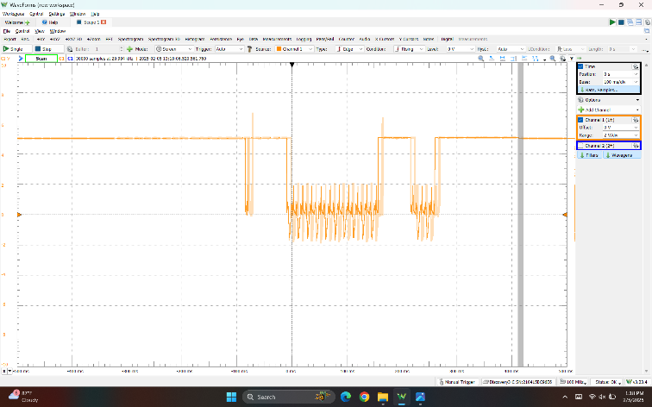

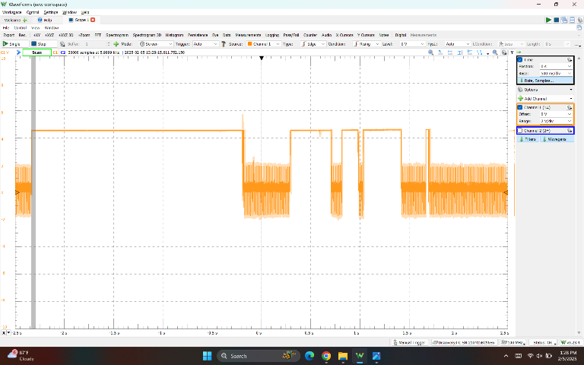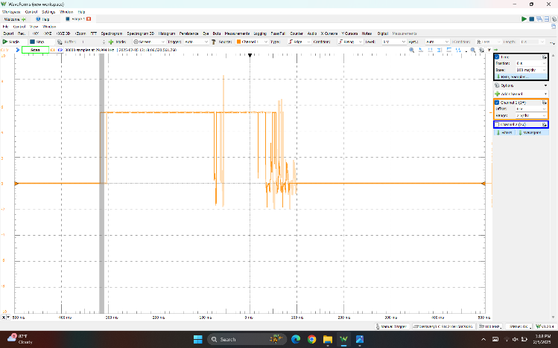

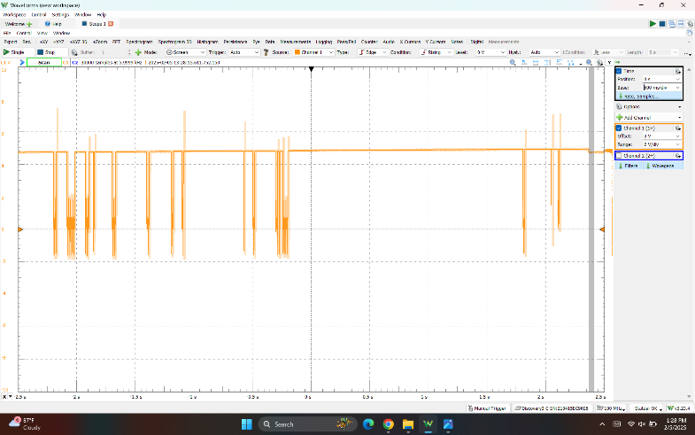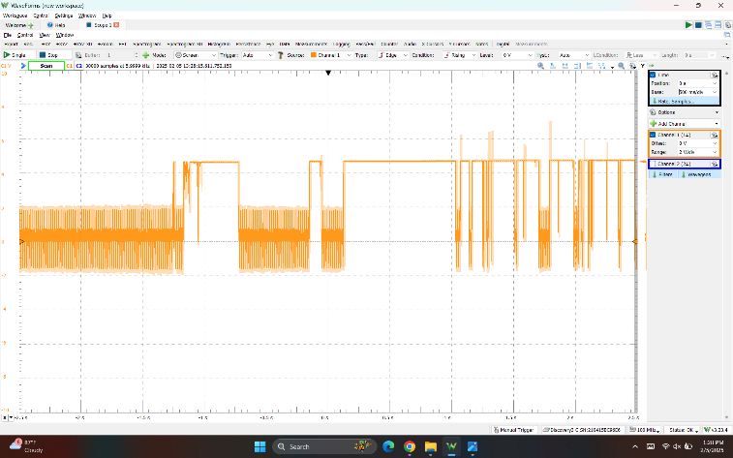

The rectified-filtered waveform shows a more stable amplitude with minimal fluctuations. Voltage peaks remain consistent, indicating effective noise reduction by the capacitor. High-frequency noise is significantly reduced compared to the standalone piezoelectric output. The waveform stays above the zero-volt baseline, showing the presence of a DC component. The rectifier and capacitor smooth the AC signal into a more stable DC output. The frequency reflects the smoother transitions from the filtering process. The output remains consistent across trials, ensuring a predictable electrical signal

1. **CONCLUSION**

This study analyzed the electromagnetic waveform characteristics of electricity generated by a standalone piezoelectric cell (AC output) and a piezoelectric cell with a rectifier-capacitor circuit (rectified-filtered DC output). The results are as follows:

1. **Standalone Piezoelectric Cell (AC Output)**  
   The raw output showed irregular amplitudes, high noise levels, and an alternating current (AC) waveform. The frequency and amplitude varied depending on the applied mechanical force, leading to an inconsistent signal. The presence of noise and alternating polarity made the output unsuitable for direct use in electronic devices.
2. **Rectified and Filtered Piezoelectric Cell (DC Output)**  
   With the addition of a bridge rectifier and capacitor, the output became more stable, with reduced noise and a consistent DC signal. The improvements in stability and reliability make this configuration more practical for energy-harvesting applications and electronic integration.